Microsoft account

[Company name]

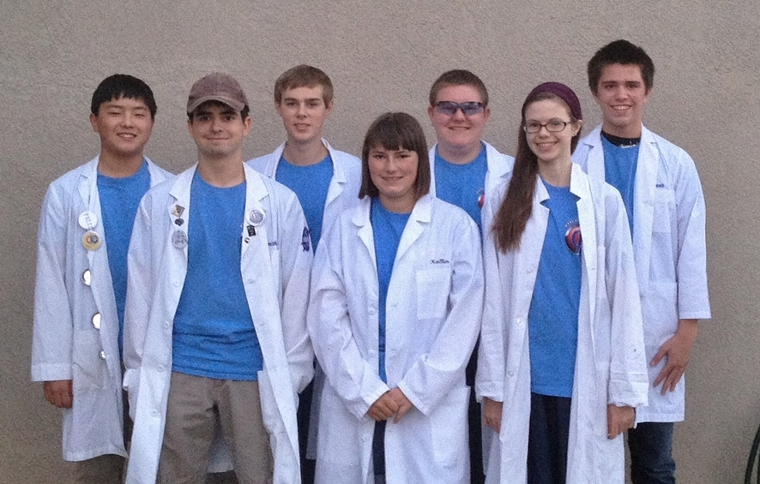

PHI Ω ENGINEERING NOTEBOOK

BIOS

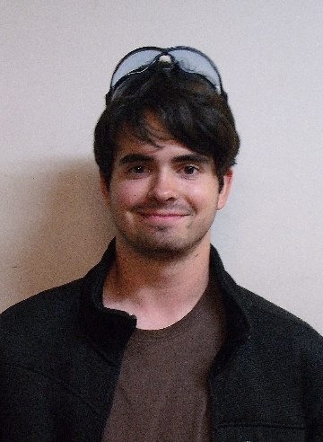

Jonathan Lokos 4th year on team

FAVORITE JOB ON TEAM: Team lead, hardware, 3D modeling, and driving.

HOBBIES: Robotics, airsoft, SCUBA diving, kayaking, and hiking.

INTERESTING FACTS: I am known in the robotics community as the “Beard of Knowledge”. I have been building and designing since I was three years old.

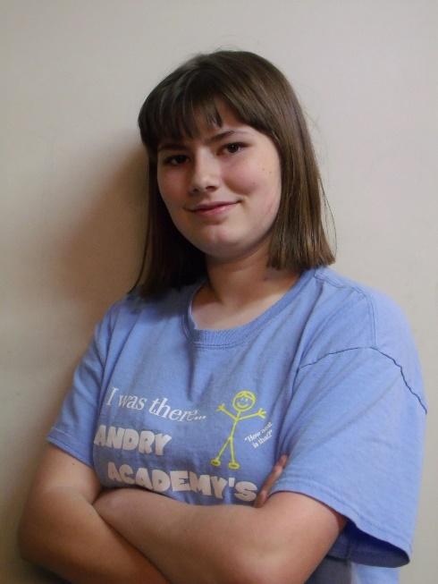

Kaitlin Cox 3rd year on team

FAVORITE JOB ON TEAM: Driving the robot and working in the notebook, as well as learning to write basic software

HOBBIES: Creative writing- particularly medieval fantasy stories and fanfiction- art, computer programming and game design, and roleplaying

INTERESTING FACTS: Over the course of the 2013/2014 school year I wrote the rough draft for a novel that is more than 110,000 words in length. I am currently editing the manuscript. I am also attempting to make a computer game using the Construct 2 platform. I am a keraunomaniac, which means I have an abnormal obsession with lightning. Not everything I say is meant to be taken literally.



Eddie Pierce 3rd year on team

FAVORITE JOB ON TEAM: Hardware design, LabView programming

HOBBIES: Playing clarinet, PC gaming, novel writing, sketching, airsofting

INTERESTING FACTS: I have been known on the team as the designated target for all robots. For my first year on the team, I was called the Dementor, but that has since changed to Bones.

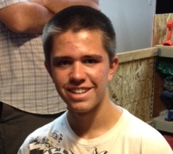

Noah Killian 2nd year on team

FAVORITE JOB ON TEAM: Software

HOBBIES: Programming, Cubing, League of Legends, Electronics

INTERESTING FACT: I’m too lazy to procrastinate so I’ll procrastinate later.

Holly Creech 1st year on team

FAVORITE JOB ON TEAM: Working on the notebook, and learning hardware.

HOBBIES: Playing the piano, teaching the piano, and writing.

INTERESTING FACTS: I love owls, chocolate, listening to music, and spending time with friends.

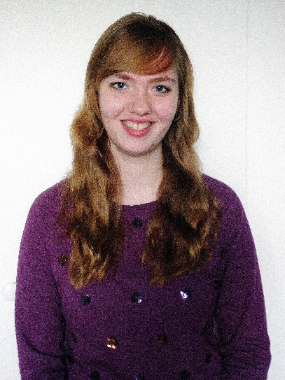



Hanna Creech 1st year on team

FAVORITE JOB ON TEAM: Hardware

HOBBIES: Photography, Baking, Piano (music), Swimming, And Drawing

INTERESTING FACTS: I enjoy my pets especially my dog and guinea pig. I’ve been doing piano for over 6 years and the flute for 1. My favorite color is blue.

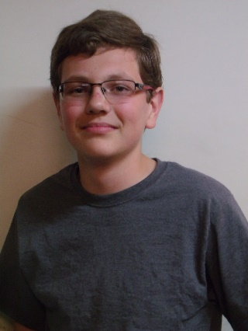

Sergei Cox 1st year on team

FAVORITE JOB ON TEAM: Hardware

HOBBIES: Softball, building things, reading.

INTERESTING FACTS: People call me different things and say my name wrong. I’m the weirdest person I know.

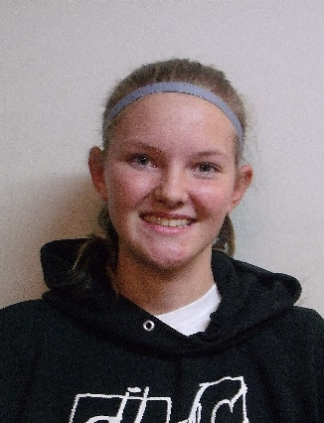

Becky Pierce 1st year on team

FAVORITE JOB ON TEAM: Software

HOBBIES: Playing volleyball and softball, running cross country and track, baking, piano

INTERESTING FACTS: I’ve been homeschooled my whole life. I helped start an FLL team in 2011. I used to be on a bowling team. I hate looking for nonexistent screws. I love the Dodgers.

Anna Leland 1st year on team

FAVORITE JOB ON TEAM: Hardware

HOBBIES: Running Hurdles, Reading, SCUBA Diving, Script Writing

INTERESTING FACTS: I manage my school’s Cross Country Team and I’ve directed my school’s play for the past three years.

MEETING LOG

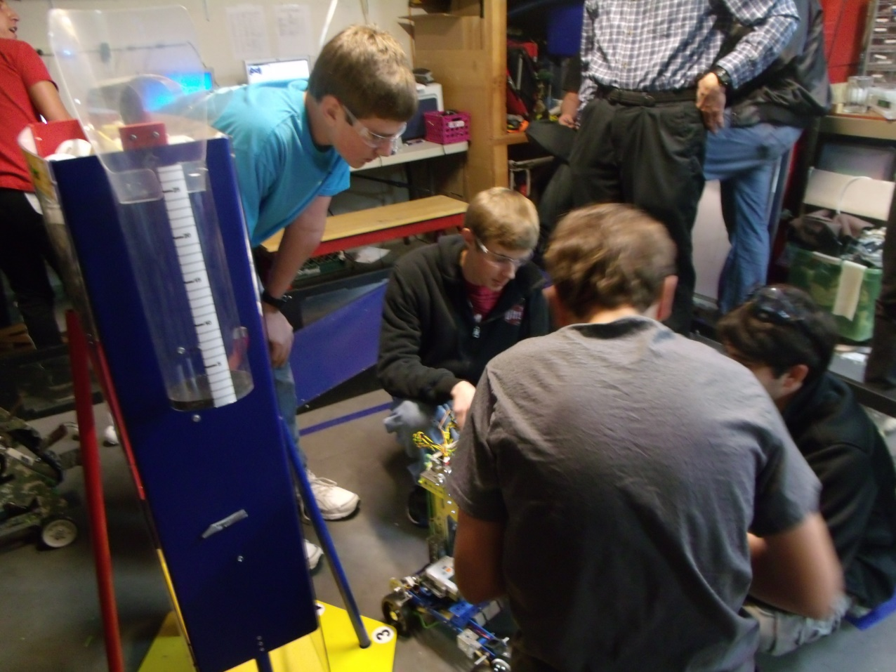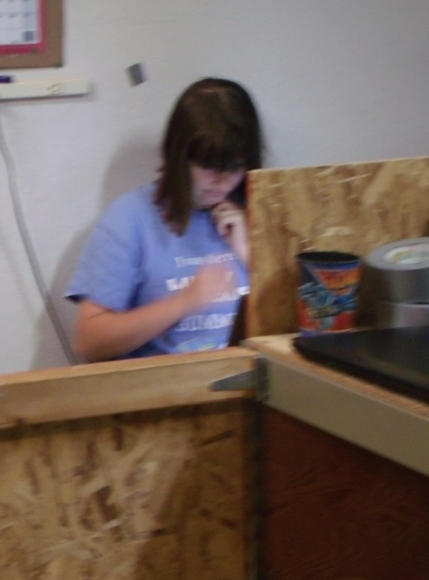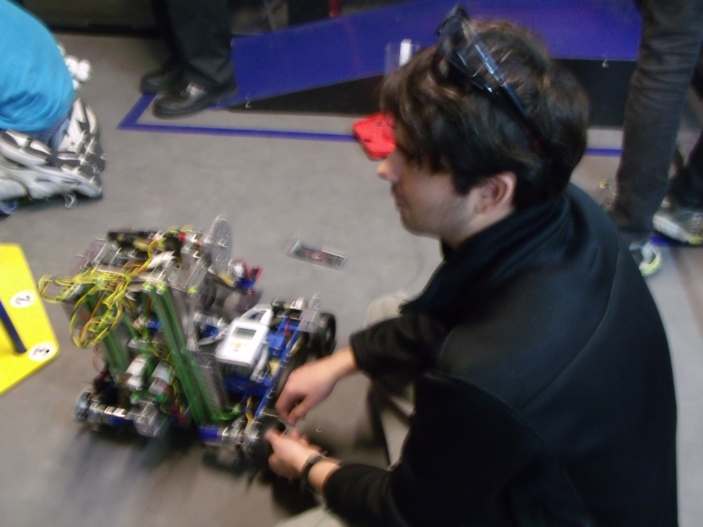

|  |
| --- |
| SAMPLE MEETING LOG- MM/DD/YYYY |
| HARDWARE  *Author initials* |
| SOFTWARE  *Author initials* |
| NOTEBOOK AND/OR OUTREACH  *Author initials* |

|  |
| --- |
| MEETING LOG- 9/8/2014 |
| HARDWARE  *Author initials* |
| SOFTWARE  *NK*  Our goals for tonight were to give some of the freshmen an intro to programming in RobotC which is the language our team uses.  Tonight we explained the basics of RobotC to the freshmen interested in learning it. We explained pragmas, includes, and basic motor controls. |

|  |
| --- |
| MEETING LOG- 9/11/2014 |
| HARDWARE  *JL*  Our goals for tonight were to rebuild both of our 2013-2014 chassis so we could mount prototypes and test them. We also wanted to brainstorm further ideas for ground intake systems.  Tonight we accomplished rebuilding and wiring both robots. We succeeded at mounting some prototypes on one of the robots and the freshmen learned how to program the other. We familiarized some of the freshmen with parts of the TETRIX kit. We also brainstormed an inverted funnel for scoring balls in the tubes. |
| *SOFTWARE*  *JM*  We further instructed freshmen on programming, teaching them about pragmas, how to control the motors, and how to create autonomies. We also explained basic C syntax. |
| NOTEBOOK  *KC*  Tonight we set up a syncing application to allow us to sync important files such as the Engineering Notebook, code files, and pictures between computers. We also set up a new, more detailed format for the meeting log. |

|  |
| --- |
| MEETING LOG- 9/15/2014 |
| HARDWARE  *MK*  Our goals for this meeting were to further our designs for collecting the balls. We also wanted to brain storm and come up with new designs for lifting and scoring the balls.  We improved a conveyer belt-like design for collecting the balls. It has cardboard paddles on it that are slightly u-shaped and are designed to scoop up the balls and drop them into the bucket. This bucket is attached to a drawer slider which is used to lift it. |
| SOFTWARE  *NK*  We continued to work with the freshmen and their coding skills. As they learn more, they will be in charge of the very basic autonomies and tele-ops while those of us that are more experienced will work with the more advanced concepts. |

|  |
| --- |
| MEETING LOG- 9/18/2014 |
| HARDWARE  *SC*  We wanted to finish our prototypes, make more prototypes, and build our game field.  The main prototype that we have been working on is a conveyor belt that picks up balls and carries it up into a bucket. The bucket is mounted on a linear slide that carries it with the balls to the height of rolling goals. We also made a smaller tube that is around the conveyor belt to help both ball sizes go up through it into a bucket and extended the width of the flaps of card board so that the conveyor belt could pick up both sizes of balls, and made a bucket to hold the balls to score them into the goals. In addition to this, we prototyped some ideas for grabbing the rolling goals. |
| SOFTWARE  *NK*  Tonight we discussed the autonomous scoring possibilities and tried to determine various strategies for scoring in the autonomous period using risk-value assessment. We are beginning to draw route possibilities. |

|  |
| --- |
| MEETING LOG- 9/22/2014 |
| HARDWARE  *CS*  Tonight we finished off the field build by assembling the last parts of the ramp, and adding the tapped lines to the floor to mark off the specified zones/goals.  Our first prototype was a small “L” shaped piece designed with a bendable edge that would fit on the back of the robot. The robot would drive backwards bending the edge to snap onto the rolling goals, and then proceed to drive to the scoring zone. This piece could also be modified with a servo to allow it to be raised/lowered onto the rolling goal lip.  Our next prototype we fitted onto a square-bot to get a better look at it. It consisted of a conveyor belt fitted to raise the whiffle balls into a holding container. Once the container was filled, an arm would proceed to raise the container, and dump the balls into whatever rolling goal was desired.  Our third prototype for the night still needs some work. It is designed to be a tube that will pull in the whiffle balls using foam prongs attached to motors. A sensor will count the amount pulled in, and will stop the mechanism at the desired amount. After this, the robot will be driven up to a rolling goal, and the balls will be deposited out of a “U” shaped piece at the top of the container. In order for this design to work, we still need NASA to cut out certain sections of the tube, and supply additional parts.  Our final design for the night consisted of an arm, holding area, and an elevator. We designed an arm to catch balls, and put them into a sloped holding container. The balls would all roll to the corner where an oval shaped conveyor would scoop the balls out, flip over, and dump them into a desired container on their “O” shaped path. |
| SOFTWARE  *NK*  We have decided on some of our autonomous goals and general software goals this season. One major objective we are pursuing is the control award. We are seeking out unique ways to use sensors and intuitive, dynamic methods for our autonomies. Our main idea for this is finding displacement from acceleration. |

|  |
| --- |
| MEETING LOG- 9/25/2014 |
| HARDWARE  *CPB*  We built some prototypes tonight. One of the prototypes we built was a little box hand that helps us pick up balls. It’s workable and easy to operate. Another prototype that we did was, attach a second linear slide for extra height. We finished wiring the bot and finished building the shield around the conveyor belt, to contain the balls when we pick them up. We also created a funnel to help guide the balls into conveyor belt. |
| SOFTWARE  *JM*  We discussed finding distance from acceleration and finding distance from IR sensor values. We were theorizing ways to use double integration so that we would be able to ascertain accurate distances from the accelerometer and are now trying to find equations that will allow us to do so. Unfortunately, double integration can greatly multiply error so we need to find a way to make measurements as accurate as possible. We are also theorizing ways we can find distance with IR finding the angles we are from the IR emitter and then using trigonometry to find our relative position. |

|  |
| --- |
| MEETING LOG- 9/29/2014 |
| HARDWARE  *HRC*  Tonight we worked on prototypes. One of the prototypes we worked on is a bucket. The bucket is lifted by a linear slide. The purpose of the bucket is for the balls to drop into it and for it then (using the linear slide) to take the balls up and drop them into the scoring goals. The bucket can also tip for more accurate and more consistent scoring. Another prototype we worked on is a way to pick up balls. It uses zip ties and no slip grip in a rectangular box. We also discovered some things we could work more on to improve. |
| SOFTWARE  *NK*  We are still looking at the various ways to perform a double integration on our accelerometer values to determine distance travelled while minimizing error. Some of the methods we have encountered are Simpson’s Rule, Trapezoidal integration, rectangular integration, and Boole’s rule. Trapezoidal appears to be the one we will use. |

|  |
| --- |
| MEETING LOG- 10/2/2014 |
| HARDWARE  *HRC*  *We started to build our robot tonight and apply some of the ideas we had come up with. The main thing we did tonight though, was wire the robot. We also worked on some new prototypes. An example of what we prototyped tonight was a way to clasp to the bottom of the rolling goals. Another example is a way to intake balls.* |
| SOFTWARE  *NK*  We’ve decided that our main focus for the autonomous period will be to score our two balls and knock down the kickstand. We would like to use the center goal for one of our balls if the robot is capable. |

|  |
| --- |
| MEETING LOG- 10/6/2014 |
| HARDWARE  *EP*  Tonight, Phi Alpha and Omega opened in prayer together, then each team discussed what they would work to accomplish during the meeting. After settling what each of the team members was working on, the teams split ways to work towards their individual goals. The meeting’s work got started with an in-depth stress test of the 3D printed plastic nacelles for Khan’s chassis. A small group constructed a simple mount for a small video camera one team member owns. After the mount was completed, it was mounted to the robot in a position such that the camera could watch the springing motions of the nacelle. After several short drops off the side of the ramp, one of the front nacelles broke in two. Through detailed examination, we observed that the plastic sheared from front to back, a place in which we were warned that shearing could occur if put under stress. Fortunately, we had a spare on hand and the nacelle was quickly replaced. After thinking of a fix to this problem, we accessed the computer model for the part and increased the thickness of the walls by three. Then the new part model was sent to our 3D printer contact for construction. Soon after, we discovered the other front nacelle was developing a crack as well. The chassis was set to the side until we could get the better replacement parts and the group that was working on the chassis turned to other projects.  During the stress testing, a separate group of Phi Omega members was working another prototype for scoring. This prototype is a large bucket with two brushes on the top for intaking the balls. Then it would dump the balls out the back of the bucket. The brushes were recycled from a previous scoring system from the previous year’s challenge.  One set of team members that moved from the chassis of the robot began reworking another of the few prototypes we have. The “Da Vinci” had a major redesign and the paddle-like intake mechanism was disassembled to later be replaced with a belt system. The rest of the team members that were previously working on the chassis helped Phi Alpha with their robot.  Shortly before the meeting ended, we stopped building to clean up the mess we had made. Then we had a short debrief detailing what each group had accomplished. Finally, the meeting was ended with prayer. |
| SOFTWARE  *NK*  We decided to go over practical ways to accomplish the tasks that we have laid out as goals for our autonomous period. These include IR trigonometric functions for positioning, dynamic control via a map of the field stored in the robot’s memory, and pre-coded static instructions. |

|  |
| --- |
| MEETING LOG- 10/9/2014 |
| HARDWARE  *KC*  Today we repaired the wheel system with new 3d-printed parts after we discovered that the original models were prone to cracking when subjected to stress. We also worked on the intake tube, and began work on the arm that will lift it. We have been working on a three-stage arm that remains parallel to the ground as it raises that, when completed, should be able to reach the highest goals. |
| SOFTWARE  *NK*  Tonight, we decided to continue in teaching some of the newer members about the software we use so that they can be ready to help with the coding of the robot. We are still mostly covering the basics of the language with them and we have started some of the built-in RobotC functions such as motor control. |

3

|  |
| --- |
| MEETING LOG- 10/13/2014 |
| HARDWARE  *HMC*  Tonight our team mounted the arm structures onto our robot, and worked on our ball intake brush system. Although they both still need some work, we have made progress. Some of the seniors worked with our team to locate parts from past years that we could recycle and work into this year’s robot. We continued perfecting the video, and continued to work on setting up this year’s notebook. At the end of the night we were all able to view the stage of the video we were at, as a group. |
| SOFTWARE  *NK*  We continued in attempting to gain displacement data from acceleration. Being a double integration, error tends to propagate quickly and so we are trying to find ways to optimize the code and minimize this. One big factor is sample rate and so we are trying to take as many samples per second as we can. |

|  |
| --- |
| MEETING LOG- 10/16/2014 |
| HARDWARE  *SC*  We made some chain and cut metal for the three joint arm. We also drilled the holes that the chain gear runs on and geared it to power the arm. Then when we tried to assemble it. We found that the length between the gears that the chain runs on was either too long or too short, so we marked where the gear would need to go by holding the chain on the gear and marking it. Then we drilled the holes and tried to mirror that on the other pieces of metal. |
| SOFTWARE  *NK*  We looked into what it would take to determine the IR’s position from the top of the ramp. We found that regardless of the IR’s orientation, you could not get 3 unique values from the positions of the beacon. We decided to explore other options for performing altering-position related tasks. |

|  |
| --- |
| MEETING LOG- 10/20/2014 |
| HARDWARE  *Author initials* |
| SOFTWARE  *NK*  Tonight we looked at our previous tele-ops and decided to see what room for improvement there was. One issue we found with the previous program was that in our use of stick-shaping, we were limiting maximum motor output to about 59%. We fixed this by finding a new curve for our stick shaping. We succeeded in finding one that the drivers liked. |
| NOTEBOOK AND/OR OUTREACH  *Author initials* |

|  |
| --- |
| MEETING LOG- 10/23/2014 |
| HARDWARE  *Author initials* |
| SOFTWARE  *NK*  One of the things we have always done is separate tasks in our tele-ops. This year we decided would be no different. We have one task for driving, another for button control and a last one for any random processing the robot needs to perform. |
| NOTEBOOK AND/OR OUTREACH  *Author initials* |

|  |
| --- |
| MEETING LOG- 10/27/2014 |
| HARDWARE  *HRC*  This week we spent a lot of time preparing for our yard sale. Some of us made signs to advertise it. We scheduled each person’s shift for the yard sale so that there wouldn’t be shifts without enough workers and vice versa. The team worked to complete the final hardware implementation. Also, we developed some autonomy programs. |
| SOFTWARE  *NK*  One thing we found when talking to our drivers about the tele-op is that some of them preferred tank drive while some still preferred the traditional single -stick drive that we have been using. We decided to appeal to both groups by making the Select button a toggle between tank drive and single-stick drive. |
| NOTEBOOK AND/OR OUTREACH  *Author initials* |

|  |
| --- |
| MEETING LOG- 10/30/2014 |
| HARDWARE  *SMC*  Our goal was to put motors on both sides of the arm. With one arm we didn’t have enough power to lift the arm up. We worked on the three joint arm and were trying to figure out how to make the robot fit into dimensions. One of the motors stuck out of the dimensions and we couldn’t flip it around. We needed to gear it so that we would get enough torch so that we don’t burn out the motors. We found that our idea was too complicated and decided to work on a new idea. |
| SOFTWARE  *NK*  Tonight we worked some more at our distance from acceleration software. We are continually getting more accurate. We are still experimenting with various integration methods from trapezoidal integration to the classic physics equations which were founded using the integral of acceleration to find velocity and the integral of velocity to find displacement. These can possibly work because even though it is not quite constant, we assume it is constant between samples and use this for the equation input. |
| NOTEBOOK AND/OR OUTREACH  *Author initials* |

|  |
| --- |
| MEETING LOG- 11/3/2014 |
| HARDWARE  *BP*  We changed the three joint arm to be sliders. The reason was because it was a simpler design and we could have the bot ready in for competition. We installed the winch to the back of the robot to make the slider arms go up. We also made a few tweaks to the ball intake to make it so both balls can easily be fed into the tube. After that, we wired the bot and checked all the wiring to make sure it was clean and acceptable. |
| SOFTWARE  *NK*  Tonight we worked some more with the newer members showing an interest in code. We still prepping them to be able to write their own basic autonomies and tele-ops as well as giving them the knowledge to be able to troubleshoot when things go wrong. |

|  |
| --- |
| MEETING LOG- 11/6/2014 |
| HARDWARE  *HRC*  On Monday we put a servo on the tube that opens and closes to let the balls out. Later that evening we re-wired most of the robot again so that it can work and run more smoothly. Also, we attempted wiring the arm, making sure it could reach to the top of the linear slides. We put on a Samantha, mounted an NXT, and placed the Battery on the robot. We tweaked around to improve the overall design. |
| SOFTWARE  *NK*  Tonight we again looked at possibilities for earning the control award. Our distance from acceleration program is close, but not accurate enough to be used in its current state. Our software to use the encoders has a relatively high error margin but is still a bit more accurate than our current distance from acceleration program. We are now trying to find another way to give us a shot at the control award. We are looking at ways to effectively zone in on the IR. |
| NOTEBOOK AND/OR OUTREACH  *Author initials* |

|  |
| --- |
| MEETING LOG- 11/10/2014 |
| HARDWARE  *S.C.*  Our goals were to finish wiring our robot, do drivers practice and to put a servo on our tube that flips and scores the balls. We needed a long wire to run up our linear slide but we didn’t have the wire we needed. So we put a couple braces to stabilize the linear slide and we wired our winch that lifted the slide. We thought that it would be good to have another robot so that some of the new people could practice traveling around and playing defense so we built another square robot. The square robot is just a simple chassis that is run by two motors and some chain. The last thing we did was to test the individual units and make tweaks to it. |
| SOFTWARE  *NK*  Since we could not get 3 unique values from any position on the ramp, we had to look at a different way to determine the IR’s position quickly. What we did find as that at the top and bottom of the ramp, there was a solo value and also two that were the same. This does not give you the IR position. However, we found that the top duplicates were offset from the bottoms by one and so we were able to use this information and take the IR reading twice, allowing us to narrow down the IR to a single position by the second sweep. |
| NOTEBOOK AND/OR OUTREACH  *Author initials* |

|  |
| --- |
| MEETING LOG- 11/13/2014 |
| HARDWARE  *Author initials* |
| SOFTWARE  *NK*  Now that we can find IR, we need a way to navigate to it. We decided on trigonometry. One way to create a triangle is to have two IR sensors as one vertex each with the beacon being the necessary third. Our other idea is to record the angle between the sensor and the beacon from one position, drive a set distance forward and then find this angle again thus creating the second vertex from the same sensor. We can use this triangle to get any information we want about our position relative to the IR beacon. |
| NOTEBOOK AND/OR OUTREACH  *Author initials* |

|  |
| --- |
| MEETING LOG- 11/17/2014 |
| HARDWARE  *Author initials* |
| SOFTWARE  *NK*  Today we decided to code some of the specifics for the robot into the tele-op so that we could test out the robot as a whole as it was ready. We added support for the buttons and triggers and individual components of the robot. |
| NOTEBOOK AND/OR OUTREACH  *Author initials* |

|  |
| --- |
| MEETING LOG- 11/20/2014 |
| HARDWARE  *Author initials* |
| SOFTWARE  *NK*  Tonight we decided that, in spirit of the control award, we need expandability for more sensors than the three that the NXT allows. Our options were a multiplexor and a SuperPro prototype board. We chose the prototype board due to the freedom it allows for. We will probably use it with a 10-dof imu using I2C protocol. |
| NOTEBOOK AND/OR OUTREACH  *Author initials* |

|  |
| --- |
| MEETING LOG- 11/24/2014 |
| HARDWARE  *HRC*  Tonight, we changed our conveyer belt. Our new conveyer belt has chain with nails instead of pins. There are two nails every four inches that are secured on by electrical tape. On the nails we put foam paddles. The paddles are a T shape. |
| SOFTWARE  *NK*  After more research, we found that the prototype board does not natively support acting as a master for I2C communication. We have decided to take on the challenge of coding a soft-I2C master. One issue we are concerned with regarding this method is that I2C can take time and if we have to control the prototype board using I2C and then a second I2C layer to retrieve data from the sensor, it may take too much time and harm our sampling rate for finding distance from acceleration. |
| NOTEBOOK AND/OR OUTREACH  *Author initials* |

|  |
| --- |
| MEETING LOG- 11/27/2014 |
| HARDWARE |
| SOFTWARE  *NK*  We now have a prototype board and a GY-80 imu. We have begun coding the I2C master and are testing as we go. We are able to fully control every port on the prototype board so that is a good start. We have not had a successful read as of yet but we are still trying. |
| NOTEBOOK AND/OR OUTREACH  *Author initials* |

|  |
| --- |
| MEETING LOG- 12/1/2014 |
| HARDWARE  *Author initials* |
| SOFTWARE  *NK*  We are having a lot of trouble trying to get the values from the sensor using this double I2C communication. We are going to temporarily put this off as we are getting closer to competition. We decided that we should create a back-up option for moving accurate distances in our autonomous period. We decided on using standard encoders. We are looking at our team’s traditional move function and attempting to increase its accuracy with a better calibration. |
| NOTEBOOK AND/OR OUTREACH  *Author initials* |

|  |
| --- |
| MEETING LOG- 12/4/2014 |
| HARDWARE  *Author initials* |
| SOFTWARE  *NK*  After failing to significantly increase the accuracy with a better encoder calibration, we are looking at other parts of the function in an attempt to reduce error such as slide at the end and inaccurate distance logging. |
| NOTEBOOK AND/OR OUTREACH  *Author initials* |

|  |
| --- |
| MEETING LOG- 12/8/2014 |
| HARDWARE  HRC  After several of Omega’s team members attended Phi Alpha’s competition and we saw problems that where regularly occurring with other teams robots so we decide to re-design our robot. Tonight we took the tube off Khan and built prototypes for our new design. Our new design is going to have chain on the wheels. It is going to use several brush to take in the balls and up to a bucket. The bucket is then going to be lifted to the appropriate height by three linear slides. The slides will all be on one side. We also got to do some practice driving. |
| SOFTWARE  *NK*  Unable to improve this move function to an acceptable accuracy, we decided to scrap it and completely start from scratch. We came up with an idea for a custom PID control that allows you to set the move at a speed in inches/sec. |
| NOTEBOOK AND/OR OUTREACH  *Author initials* |

|  |
| --- |
| MEETING LOG- 12/11/2014 |
| HARDWARE  *HRC*  *Tonight, we started working on our new design. We measured and cut out the plastic for our new bucket using a dremel, then we assembled it. The linear slides where taken off, disassembled, and reassembled to be three on one side verses two on both sides. Also, We put on the brushes using zip ties.* |
| SOFTWARE  *NK*  With our custom PID control working, we are also looking at ways to increase precision further. We decided on a ramp down. After messing with graphs, we decided on a function we liked that provides for a smooth and gradual ramp-down based on progress completed. |
| NOTEBOOK AND/OR OUTREACH  *Author initials* |

|  |
| --- |
| MEETING LOG- 12/15/2014 |
| HARDWARE  *KC*  Tonight we continued to work on our hardware revisions. Our design now uses a scoop in the front and works much like a vacuum cleaner without the suction. It has a brush made of zip ties in the front that rotates and flicks balls back into a bucket, where they are stored. This bucket is independent of the scoop, and is attached to a drawer slider which lifts the bucket up. We plan to add a hook mechanism to the back of the robot as well to catch the base of the scoring tubes and hold them in a static position while the bucket dumps the balls in. |
| SOFTWARE  *NK*  We are working on calibrating the counts per inch for the new move function. We currently have 1/2” error margin and are aiming for 1/16” in a renewed attempt for the control award. |
| NOTEBOOK AND/OR OUTREACH  *Author initials* |

|  |
| --- |
| MEETING LOG- 12/18/2014 |
| HARDWARE  *HMC*  Tonight we were able to mount the bucket onto our new robot design. We had to add supports to the bucket to stabilize it. We used a variety of tools to aid us in our work. We used a dremel to shorten an axel that was in the way, we used rivets to fasten the bucket together, we used the heat gun to melt and bend the plastic according to our needs, and we mounted the bucket with nuts and bolts onto our linear slide. We also fixed some issues we ran into with the linear slides, so, at the time being, they are functioning properly. |
| SOFTWARE  *NK*  Today we worked on creating the autonomies relevant to this competition using mostly static pre-coded instructions. We found that it was tedious to recreate each autonomy for each move pattern we wanted and so we decided to start coding a gui that allows for a graphical interaction in autonomy creation. |
| NOTEBOOK AND/OR OUTREACH  *Author initials* |

|  |
| --- |
| MEETING LOG- 12/22/2014 |
| HARDWARE  *HMC*  Tonight we set the goal, to finish hardware on our robot. Although there will be modifications, we have our newest design almost completed. We met extra hours in order to keep on schedule as there will be no meeting on the 25th due to Christmas. Hardware included mounting the bucket, mounting the Samantha, sawing, drilling, and working with metal and plastic to build supports for servos. We intend to meet later in the week for driver practice. |
| SOFTWARE  *NK*  We are writing the autonomy creator in C# for Windows and will post it online when we finish for other teams to use if they want. It will provide a C file defining movements in basic commands such as “Move(Inches, Speed)” and “Turn(Degrees)” and also output a picture of the autonomous plan for documentation. |
| NOTEBOOK AND/OR OUTREACH  *Author initials* |

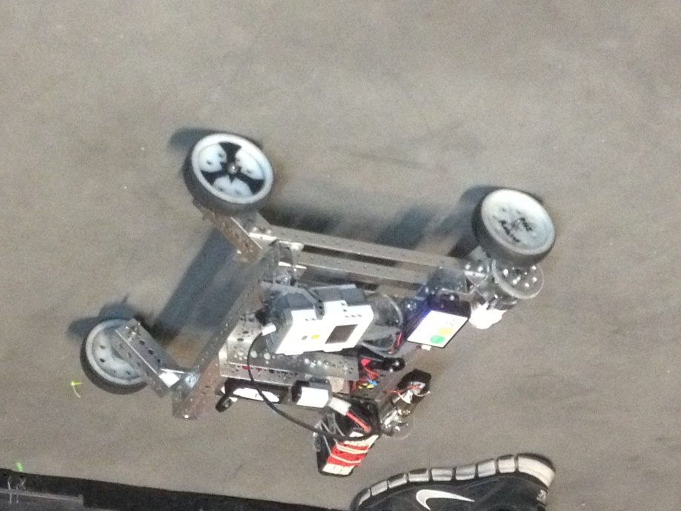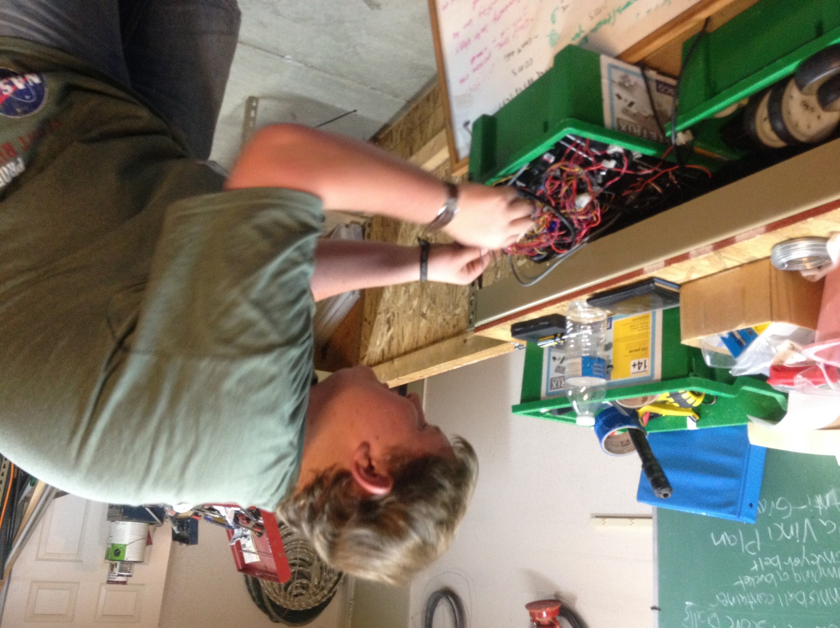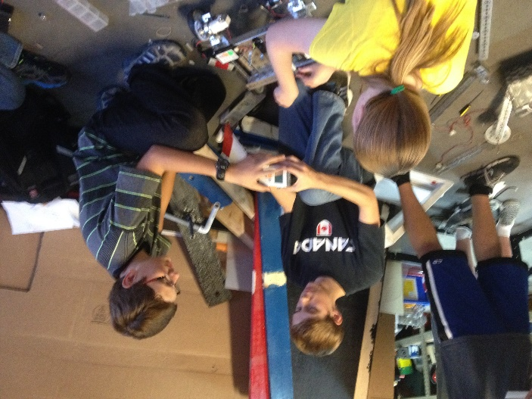

HARDWARE

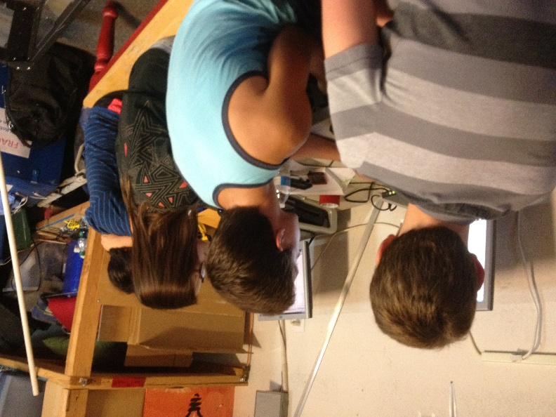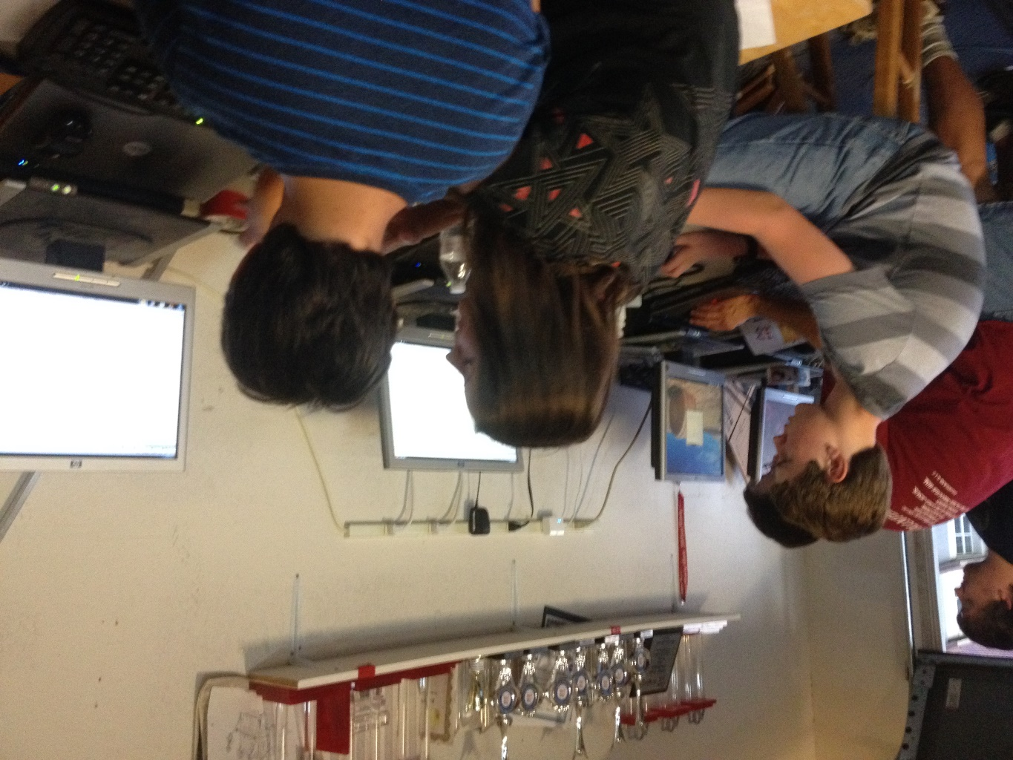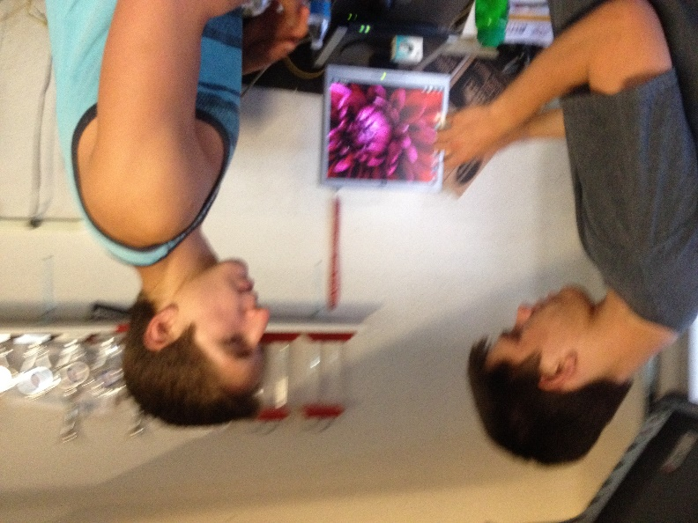

SOFTWARE

FUNDRAISING

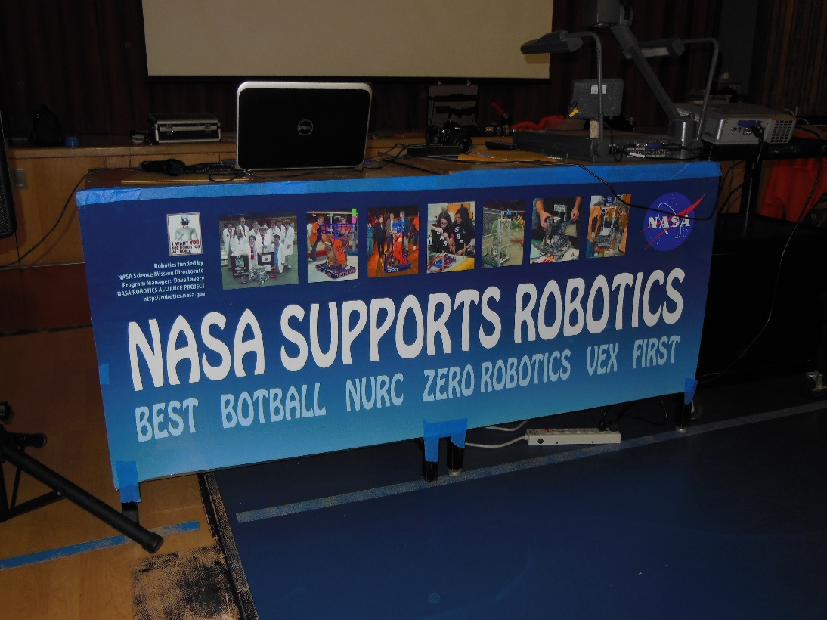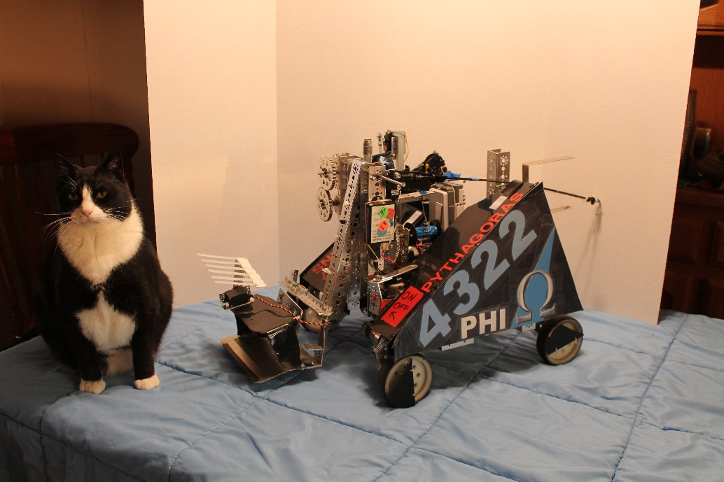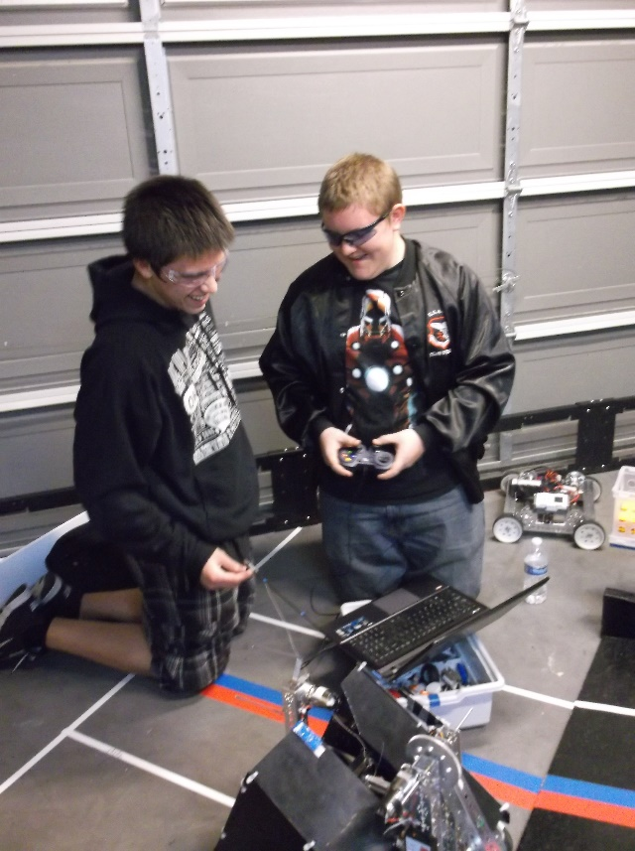Promote Award Video Entry:

TEAM ORGANIZATION

PROMOTE VIDEO

This year Phi Robotics decided to make an entry for the Promote Award. Both Phi Alpha and Phi Omega collaborated to make a video submission for the award. The teams came together and submitted their answers to this year’s challenge- Why I Chose FIRST. Then we compiled those answers and combined them into a 60-second video.

We wrote several drafts of the script we used for the video. The final draft is included below:

Person A - Why First?

Person B - Why First?

Person C - Why First?

Person D - Why First?

-Screen shows a collage of "Why First?"

- Screen shows a large "WHY FIRST?"

Luke - I chose FIRST because it's a way to learn new things ()

Kaitlin - to challenge ourselves ()

Hanna - to give us head starts to our futures ()

Mike - I chose FIRST because it builds teamwork and cooperation ()

Person B – It brings together new friends (Cole)

Person C – It provides a way to interact with others who share our interests (Sergei)

Person A -I chose FIRST because it teaches responsibility (Becky)

Person B – It teaches us to act independently and take initiative (Holly)

Person C – how to become both good leaders and good followers (Jonathan)

Person D – to learn to sacrifice for the good of others (Eddie)

Person E – to learn diligence, confidence, and determination (Holly)

Person F – and to become more creative (Cici)

Person A - I chose FIRST because it's a way to share gracious professionalism (Mike)

Person B - to encourage others (Scott)

Person C - to help others (Becky)

Person A - I chose FIRST because it's a way for us to reach out to the community (Kaitlin)

Person B - to participate in and host events (Kayla)

Person C - to partake in healthy competition (Hanna)

All- I chose FIRST because it’s a way to have fun!

*credits*

Troubleshooting

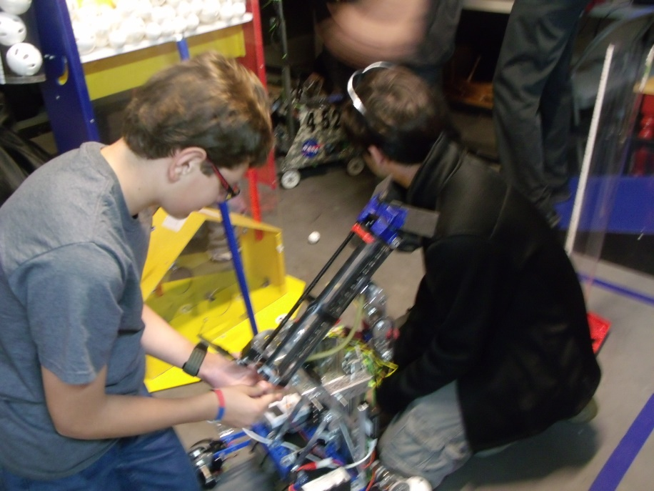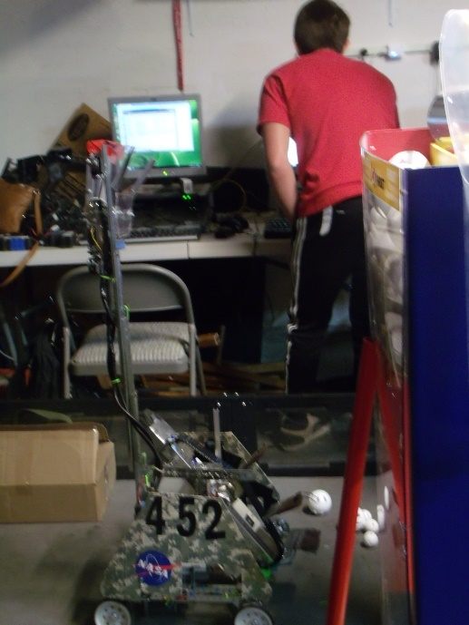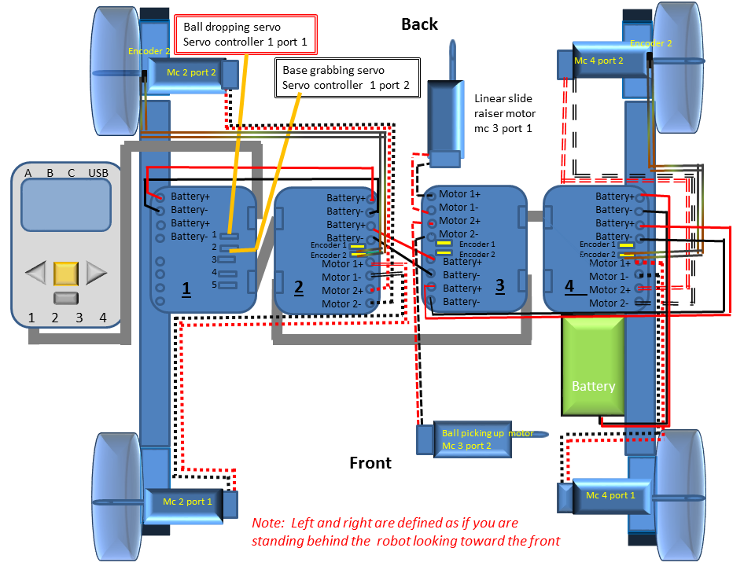

Trouble shooting

Here are some of the main troubles that we faced this year and the solutions that came about. Here we also have some of our main robot designs and how the changes came about over time. This also shows our proses in learning how to develop a mindset that doesn’t let you give up until you know that you tried everything.

Can you handle the shock?

We decided to make a robot chassis that has shock absorbers. On order to do this we needed to make our own parts. We ordered the parts to be metal shopped from NASA we also designed some plastic pieces that NASA also printed. One piece is a rectangular channel that the motor is attached to. Another one is a little square piece that holds the supports that hold the two halves of the robot together. When we put the robot together we used some surgical rubber tubing to make the shocks.

As we put more on the robot it got heavier and heavier it got so heavy that the shocks collapsed. So we ended up putting more surgical rubber tubing on it to give it more spring. That made it be able to hold its load up.

After we made the chassis we drove the robot off the ramp to test the shocks. One of the times we drove it off the ramp the plastic printed part that the motors are attached to sheered in half. This occurred because the plastic was weaker than the metal that we usually use. So we modified the piece and made it thicker so that it could take more.

Later when we were driving the robot around the chain kept coming off the gears. We looked at the bottom we found that the screws were eating their way through the plastic. We sent in more requests to have more be made and to put metal on them to keep the screws in. We did a temporary fix by putting washers under the screws.

When we were wiring we put the robot down wrong and one of the pieces that hold the two half’s of the robot together broke in half. And one part of the robot started dangling. We found another of those pieces and put it on. We also sent in the request to make more and to have those metals shopped.

Rise of Khan I

Our first design was a threefold arm that went up with a tube that on top called the Da Vinci tube. The threefold arm had two metal pieces or the tube and a metal piece that is parallel to the other metal c channel.

This metal piece is parallel to this one

Threefold arm

And this tube is parallel to this bar

The first problem was that the holes that we drilled in the metal pieces were not lined up right so the chain that we needed to make the arm go up and to keep the arms parallel was too long and if we shortened the chain it was too short. So we drilled more holes in the bar and the chain fit a little better but no perfectly so we used zip ties to attach the chain together in the center. The zip ties still allowed the chain to move but it also tightens it.

Another problem we had was that we could not get the arm to fit into dimensions because we had one arm on each side and we needed to put a motor on each side but when we did this the motor would stick out. Because of the design we needed worm gears to keep the arm in its proper position without them the arm would just slip back and not stay up but we did not have enough room because the tube took up too much space. We spent hours on the arm and found that we could not push it into dimensions. We then decided that it was not worth the time to make the arm work and decided to work on another idea.

Collapse of Khan II

Our next idea was a robot that had two linear slides and the Devin chi tube between them. The tube would use a conveyor belt that we made to bring balls up and to score them. The problem with the bot was that we couldn’t make a good enough belt for it that would actually bring the balls to the top.

Before we had the belt we made some spinning blades out of Styrofoam. The blades would jam the balls in the tube.so we went to our first belt was made from Styrofoam and we could not get the belt to move. We then put grippe cloth on the bottom of it to help it grip the axel that was supposed to move it. But even with the cloth there still was too much friction to overcome and the belt would not spin.

Our second belt was made from chain we took some of the pins out of the chain and replaced them with small nails. Then we put some paddles on the nails by taping some Styrofoam to them. The problem with that was that the chain was too loose because the nails gave it more give than the pins that were there originally did.

Eventually we gave up on using a belt or chain to move the balls up because. So instead we had the whole tube just rotate up so that the balls would just roll out into the tube. The linear slides that moved the tube up had way too much weight on them because of the whole scoring mechanism on top. So we needed to put another motor on the lift to make it go up. Even with another motor the motors would skip gears and strain to get up. We decided to not go along with this idea because it took a long time to get it working and it also took a long time to make it work and the whole thing was just too heavy and complicated.

Our wiring misadventure

In the last one of the meetings we found a problem with our robot. The problem was that as you drove the robot forward and then suddenly changed direction the whole robot would stop working. Also the battery would drain very quickly and we burned out a fuse. First we thought that it was a programing problem, so we tried a different program. But it still did the same thing so we flipped the robot over and did some more tests. We did enough tests so that we could predict when the robot would die.

We decided to change out the wires that connected to the robot and connected them to a different motor controller. The results were that instead of the whole robot dying only one side did. Because of this we concluded that only one motor controller went out and that it was the first in the chain. If the first motor controller went out the rest of the controllers would not be getting any power causing nothing to run. We deduced that something was short circuiting we couldn’t figure out what so we decided to rewire the whole robot.

We made a meeting the next day to rewire the whole robot but when we got there we did some more tests and the robot was working. Because we didn’t do anything to the robot to fix it we still decided to go ahead and rewire. First we undid all the motors, the servos, and the power wires then we moved two motor controllers to a spot where we could access them easier. We made a plan on how to wire it the easiest way.

Then we started with connecting all the battery wires and the wires that connect the motor controllers to the NXT. Since our first controller was one for the servos and our other three were for the motors we gave the motor ones the battery priority by having them closer to the battery servos need less power so they could be further away. The wires that carry the command are running the opposite way than the power wires.

We started doing the drive motors and thought that it would be easiest to put each motor in separate ports instead of having both drive motors on each side in the same port. So we started doing it that way but as we were putting in the other motors we found that one of the motor ports was stripped in the motor controller. Because of the design we cannot remove the motor controller easily because it was one that is in the center we would have to remove one other controller to get it out. So we doubled up the drive motors to open up some more space.

One of the last things we did was to connect the servos to their proper ports and connected the switch and wired it to the motor controllers and to the Samantha unit. We also put two plastic shields to protect the wires. We ran a couple tests and it was working we were able to score our first ball in the small scoring goal.

We have encountered a recurring problem within the drive system of the robot. If a driver is moving the robot at full speed in one direction then quickly reverses the direction of the robot to full power in the other direction, the robot’s drive motors will cut out and the robot will not move again until a full reboot of the main power is performed. Due to this problem, the robot was taken to a team member’s house over the weekend for troubleshooting.

January 3rd

The troubleshooting began with a replication of the problem to be sure it wasn’t a strange fluke during the previous meeting. From there, the team member disconnected one set of motor wires from the motor controller and moved them to a second motor controller not housed within the robot, then wired a makeshift power jump to this second controller, making sure to disconnect the rest of the motor controllers in the main daisy chain. From here, they tested for the problem again. This time, only one side of the robot, the one plugged into the new motor controller, encountered the same problem, a killing of all power to the motors. This showed a possible issue with the motor wires on that side.

The team member then replaced the motor wires on that side with brand new wires to test. After a repeat of the same test, it was shown that not even this fixed the problem. They then tested the continuity of the wires for all four motors with a multimeter. This test proved that all four motors were receiving power correctly. They then plugged all four motors into the external motor controller in pairs and jumped the main power circuit to this controller, disconnecting all of the main daisy chain of wires. This bypassed every piece of wiring on the robot to give a final test of the drive system. This test gave the same results, and the team member stopped for the day.

January 4th

After some recommendations by a mentor, the team member tried one more option. The mentor had a theory that the motors were drawing too much amperage from the motor controller, thus tripping the safety switch within the motor controller. The team member activated the teleop and moved the stick on the controller slowly in every direction to test the theory. The robot moved in every direction without encountering the recurring drive problem. This showed the theory was correct by demonstrating that with a lower amperage draw, the robot would drive properly. The solution to the problem is to give each of the motors their own port in the motor controllers. This would require a modification in the code, but it would help. After taking the robot back to the garage, another mentor made the suggestion that they should change the power of the motors in the code first, due to the much simpler process for doing this over the addition of a motor controller.

We tested the limit on the power by putting the robot on a crate and making a quick program that would just spin the wheels forwards and then reverse them. As it was not working we kept putting more and more limit on the power. We then got to a point where we would be going to slow and decided to have the program make the robots wheels do a complete stop before reversing direction. This made the robot last longer but in the end it still died.

We then were wondering if the servo controller was the problem. To check it we unplugged it from the chain and plugged in just the motor controllers. We then tested it on the crate again but it still did not work. We then decided to separate all our motors because our mentor found on the web site that somebody had the same problem. The problem ended up being that when we put two motors in one port they draw more power when they reverse direction.

We knew that we could not separate the motors without adding a new motor controller because one port one controller was not working because it was stripped. So we added another motor controller on top to replace it because it would be very hard to take it out and put a new one back in and we do not have enough time. So we put a new one on and wired it and it works!!! Because of our wiring changes we had to redo our wiring diagram.

We tested it in the end by doing drivers practice where we tested it as we were driving and we were giving our new team mates a chance to drive the robot. Our con conclusion was that the motors were pulling too much power causing some thing in the motor controller to set off making the robot not work.

The supremacy of Khan III

We decided to not use the tube because it vas to heavy and it was hard to make it work. So we came up with a small light bucket that could easily go up or down. This allowed us to only need one linear slide. This gives us more room on the robot and an extra motor to play with.

Our current design has not had as many problems but we still have had a few. The main problems that we have had with this design have been that the bucket that we use to score the balls with has cracked a couple times, that our wiring has had problems, that our gears kept slipping, and that our linear slide was very hard to bring down.

Our bucket we plan to redo with stronger plastic and make it out of one piece of plastic. We separated our motors which has solved most of our wiring problems. We solved our gear skipping problem by putting chain to drive our robot instead of doing it with normal gears.

Slide all the way up

One of our main problems has been our linear slide. Our linear slide had problems going down because there was so much friction that it always got stuck in one part. It was always one part of it that got stuck. So we tried lubricating it with WD40 but it did not help. So we decided to unstring the slide and see if that helped it. We unstrung it and we let it down almost all of it went down but one part did not. So we kept moving the part that did not go down and we could hear a noise like there was dirt in the little balls that bake it slide. But there shouldn’t have been any because the lubrication should have flushed it out.

So we decided to remove a part that we had screwed in there to see if it was that part. The part was there so that we could extend the slide all the way up. Then we lowered it again but it did not help at all. So we decided not to extend the linear slides all the way so that we could still score with the rest. Without that half of the slide we could still score in the tall goal but the dis advantage is that we could not score in the center goal.

We then decided to try to use 50lb fishing wire to raise the slides. The par cord that we used made too much friction exist and the motor strained to extent the linear slides. After a few runs up and down the fishing wire snapped. So we ended up using some string that is not as thick and is slicker than the par cord.